Veneta Emergency Shelter
Volunteer Training
This document provides training for volunteers for the Veneta Emergency Shelter.

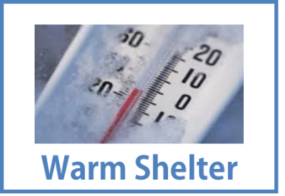
MISSION STATEMENT: To provide emergency shelter to our neighbors during times of extreme weather or disaster.
When the temperature is 28 degrees Fahrenheit (30°F) or below and during other hazardous conditions, the Community Shelter operates 4:30pm–8:00am. Check the website for the activation status.
Fernridge Faith Center, 25133 E. Broadway, Veneta, OR 97487.
Website: www.fernridgecommunityservices.com
Contact Us
Please contact the Volunteer Coordinators for questions or to volunteer:
- Junie Gangle (Shelter Coordinator) 541-556-3336
- Isa Jennings and Jabrila Via (volunteer coordinators) venetawarmshelter@gmail.com.
EXPECTATIONS
Even though a church is hosting the shelter, we are not here to evangelize. This is not a “church thing,” rather a “people thing.” Volunteers should show respect for all faiths and religious practices.

Hospitality
- Be welcoming. Smile! ☺
- Be flexible and teachable.
- Ask questions.
- Be willing to assist where asked or needed.
We are not expected to do the following:
- Drive or give rides to guests.
- Provide money.
- Judge or pry.

Rules of Respect
All volunteers and guests will treat each other with respect using appropriate behavior and language. Each person will:
- Be Safe
- Be Responsible
- Be Respectful
Well-behaved pets are welcome. Food and water can be provided (check the pantry for dog food).
- Owners must keep pets leashed, crated, or have them in their control at all times.
- Service dogs MUST be leashed and under control of handler at all times.
- Owners must clean up after their pets.
Minors who are guests are welcome without a parent or legal guardian. Minors who are volunteering must be accompanied, at all times, by a parent or legal guardian.

Alcohol, Tobacco, or Drugs
Alcohol and substance abuse in itself is not a reason to exclude a guest. Sobriety is not required for our guests, but we do address bad behavior caused by drinking or substance abuse.
- Consumption of alcohol, marijuana, or other drugs (except prescriptions) is not allowed in the Church or on Church property.
- Drinking and use of marijuana and illegal substances are not allowed on church property.
  - Guests must leave the building and church property to use alcohol or marijuana.
- Guests may smoke tobacco outside at least 10 feet from any door.

When to Ask Guests to Leave
Shift/Team Leads can ask guests to leave if they cannot show respect to other guests, volunteers, or themselves. Examples include the following:
- Excessive shouting or disruptive verbal outbursts
- Behavior that creates an unsafe environment
- Verbal or physical threats to themselves or other people
Three-strike rule. As of 12/17/18, there is a three-strike rule for serious behavior issues that result in a guest being asked to leave.
- For the 1st incident, the guest can be asked to leave for that night.
- For the 2nd incident, the guest can be asked to leave that night or for a series of nights, depending on the seriousness of the issue.
- For the 3rd incident, the guest can be asked to not come back for the season.
Behavior related to substance abuse can be a reason to ask a guest to leave.
- Bad language, disruptive arguments, and fighting are not allowed on church property and may result in the guest being told to leave.
- If a guest is suspected of having or leaving inappropriate items, e.g., alcohol containers or drug paraphernalia, two people (either the Team Lead and another volunteer or the volunteers on shift) should talk to the guest privately and remind the individual about the policy of no alcohol or drugs on church property.
- If the guest cannot give a commitment to compliance to any of the guidelines, the guest can be informed that s/he will not be able to come to the shelter again.

Process for When to Ask Guests to Leave
- First and foremost, ensure the safety and security of you, other volunteers, and all guests.
- Directly address the behavior of the guest. If appropriate, you can try to de-escalate the guest with clear instructions, such as, “Please lower your voice.”
- If time allows during the incident, the guest liaison or chaperone should contact the Team Lead assigned for the night.
- If the guest causing the disruption does not comply with verbal instructions to change his/her behavior inside the building, the guest can be asked to leave.
- If the guest refuses to leave, depending on the severity of the situation:
- Always call the Team Lead.
- For emergency situations: call police (911).
- Follow up with the Team Lead after an incident occurs.
- Immediately inform the Team Lead assigned for the night of unacceptable behavior if this hasn’t already been done.
- Document the incident in the notes for the next shift regarding what happened.

DONATIONS
Shelter accepts donations via the website (www.fernridgecommunityservices.com) and checks can be made out to the Warm Shelter Fund.
Food used for Shelter is provided by Food for Lane County and donated.
We can provide certain critical items, depending on donations.
- Paper products, trash bags, and coffee items.
- Family-friendly DVDs, games, and books.
- Blankets, gloves, socks, hats, and feet and hand warmers.
- Other clothing can be donated to and picked up at Lilies of the Field at Olivet Baptist Church, 25027 B Dunham Street, Veneta; open Tuesdays and Thursdays 2:00–4:00 pm.

VOLUNTEER RESPONSIBILITIES
All volunteers are expected to:
- Remain awake and attentive and demonstrate effective judgment through each shift on duty.
- Work with and within a diverse community network of resources, in a mature, responsible manner.
- Communicate respectfully and effectively with guests, staff and community partners.
- Demonstrate the ability to utilize necessary resources to safely facilitate emergency shelter.
- Keep the pantry door locked during the time our guests are in the Fellowship Hall.
- Leave notes for the next shift, including any problems, good things that happened, and food issues.

Training
Training is mostly online
- Watch the training videos and read the manual and documents.
- Additional specialized training can occur one-on-one trainings with a trainer.
- Additional “On-the-job” training can be provided when you “shadow” a shift before you volunteer to work a shift.
- Sign up on the website and add “new” next to your name.
- For the safety and security of the program, Warm Shelter volunteers MUST be trained (in person or online) prior to working a shift.
- A family member who has not been trained CANNOT accompany a family member/volunteer who has been trained.
If interested in training, send an e-mail to venetawarmshelter@gmail.com

We appreciate you being on time for your shift.
- Please arrive 10 minutes before your shift to:
- Allow you and the volunteers on the previous shift to share information and transition.
- Be prepared to start your shift right on time.
- If you are going to be late or are unable to fulfill your shift as soon as possible, please contact the Team Lead.

Youth Volunteers at Shelter
- All youth under the age of 18 must have a Youth Volunteer form filled out and signed by a parent or guardian.
- Youth under the age of 18 must be accompanied by an adult (for example, teacher, Scout leader, or volunteer mentor).

HOW TO VOLUNTEER
- All Volunteers: Sign up on the website: www.fernridgecommunityservices.com
- If questions, contact: Shelter Coordinator Junie Gangle 541-556-3336, Shelter Volunteer Coordinator: Isa Jennings, 541-914-0644 or venetawarmshelter@gmail.com.

To Sign Up on the Website
- From the Fern Ridge Community Dinners and Community Warm Shelter home page (www.fernridgecommunityservices.com) follow the steps. On the website page https://venetadinners.org/warm.html select the Shelter button. Examples below are the Veneta Warm Shelter sign-up page.
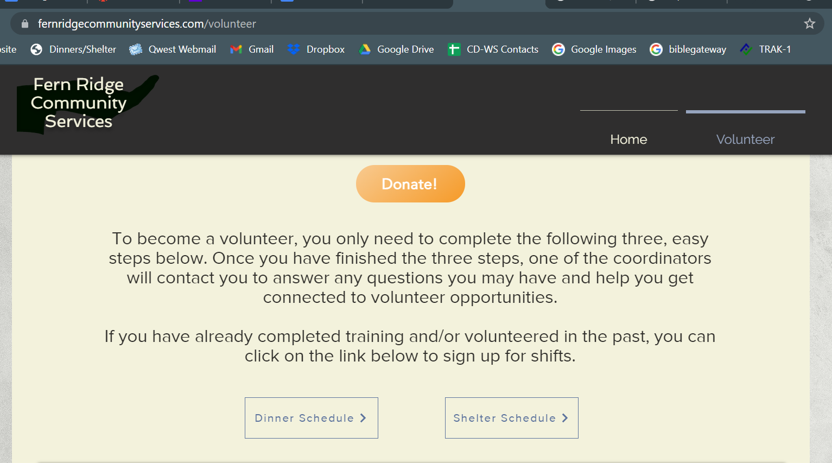

- Add your name to one or more of the shifts. Each person should have his/her own entry (i.e., own row). Do not add names of other people in the same box as your name.
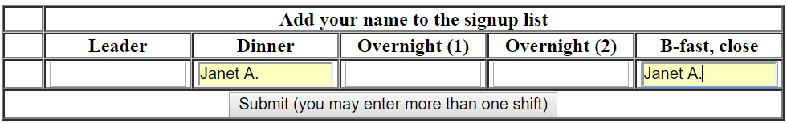
3. Select Submit.

4. Your name will appear on a row beneath the shifts for which you signed up.
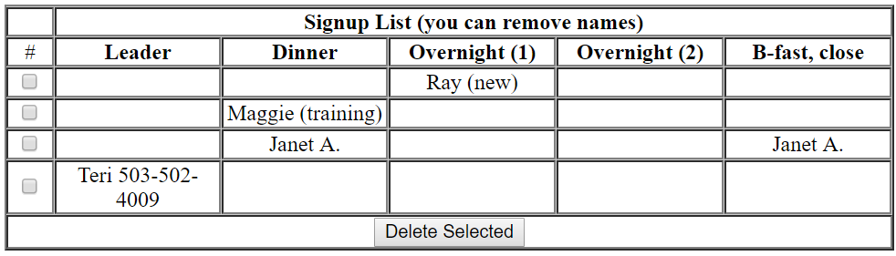
Notes to add when signing up:
- If you are a new volunteer, please add “new” next to your name.
- If you are signing up for “on-the-job” training to “shadow” a shift before you volunteer to work a shift, add “training” next to your name.
- If you are a youth (under 18 yrs. old) add “youth” next to your name and make sure your adult guardian also signs up.
- If a service animal will be present, use “+dog” along with the volunteer’s name.

To Delete Your Sign-Up
If you are unable to fulfill your shift, please notify the Team Lead as soon as possible.
You can delete the shift(s) you signed up for by removing your name from the sign-up list. At this time, you cannot select a specific shift; you have to delete all of the shifts you signed up for and then sign up again for the correct shift(s).
1. From the home page, select the Warm Shelter button.
2. Select the day of the shift(s) you want to delete.
3. In the left column, select the check box beneath the # (number sign).
4. Select Delete Selected.
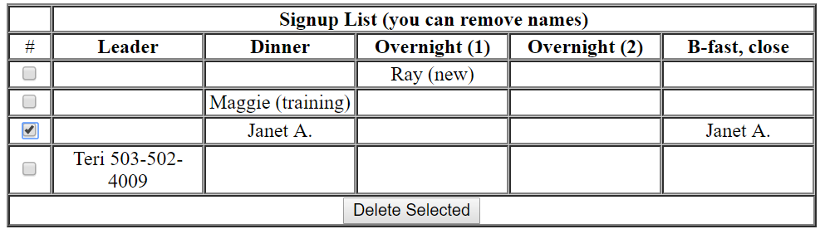

Please DO NOT remove another volunteer’s name from the sign up list.
- If you mistakenly delete someone else name from the list, please re-add it.
- If you accidentally delete a name and cannot re-add it or don’t remember who it was, please contact the Volunteer Coordinators immediately.

Veneta Warm Shelter Operating Procedures
When the temperature drops 28 degrees Fahrenheit (28°F) (or below) or during other hazardous conditions, the Warm Shelter provides a free place to take emergency shelter for the night. When activated, the Warm Shelter operates 4:30pm–8:00am in the Fellowship Hall of Fernridge Faith Center at 25133 E. Broadway, Veneta, OR 97487. Check the Fern Ridge Community Dinners and Community Warm Shelter website: www.fernridgecommunityservices.com for the activation status.
Anyone coming in the door during the hours of operation will get a warm place to sleep up to church capacity (currently up to 24 inside), along with a hot dinner and take out breakfast. Guests are often members of our community who are homeless or need to take shelter. Guests are welcome to leave and return as needed. Adult Chaperone(s) on duty will supervise behavior. (This is not an Egan Center.)
Along with a place to sleep, the shelter provides a hot meal (dinner) and a to go breakfast) and limited entertainment (music, movies, cards, games, etc.) to lift guests’ hearts from the cold and darkness.
The Warm Shelter is made possible by coordination with Fernridge Faith Center and community partners such as the City of Veneta, Veneta Homeless Advocacy Board, Fern Ridge Service Center, other local churches, and―most of all―volunteers.
We thank everyone who volunteers their time and services. Without sufficient staff, the Warm Shelter cannot open safely.
- For an online version of this training manual, see www.fernridgecommunityservices.com

Contact List
The Warm Shelter Volunteer Contacts Google sheet lists the contact information of all volunteers. This list includes guests who provide their emails and phone numbers so they can be contacted upon activation. This list is only available to the Shelter Planning Team.

Overview of Shifts
- 4:30-8:00 pm: Dinner/Greeters (2 people)
- 8:00-12 Midnight: Evening (2 people)*
- 12-5:00 am: Overnight (2 people)*
- 5:00-8:00 am: Morning/Takeout Breakfast/Cleaning (2 people)*
- after 8:00am: additional cleaning crew (1 person)

Detailed Schedule
Volunteering should be fulfilling and joyful. Come to the Warm Shelter ready to work and to enjoy fellowship with guests and other volunteers.

- 4:30 pm: Dinner/Greeter shift arrives
- 5:00 pm: Doors open
- 6:00 pm: Dinner is served
- 8:00 pm: 1st shift of Evening chaperones arrive
- 10:00 pm: Quiet time
- 12:00 Midnight: 2nd shift of Overnight chaperones arrive
- 5:00 am: Morning/Takeout Breakfast/Cleaning shift arrives
- 7:00 am: Wake up guests
  - Hand out breakfasts packaged for takeout & clean area
- 7:45 am: Additional cleaning staff arrives
- 8:00 am: Doors closed and locked
- Additional cleaning crew: comes during the day as scheduled with the shelter coordinator.

Volunteer Roles
Many volunteers are needed to operate the Warm Shelter:
- Team Leads (coordinate and oversee activated night shifts)
- Activation Communicator (posts signs and communicates opening to Sheriff and Fire Dept.)
- Shift Volunteers (cooks, entry screeners, guest liaisons, chaperones, and cleaners)
If you need to leave early or cannot complete a full shift, contact the Team Lead.
Activation Communicator will:
- Contact Sheriff Dispatch and Fire Department reader board.
- Place flags on the gates at 8th St. and Territorial and put out the yard sign.

Team Leads
Team Leads are responsible for overseeing the staffing of a Warm Shelter activation night and have access to a church key. Upon activation, responsibilities include:
- Being on call and reachable by phone in case of behavioral issues or a volunteer not showing up for a designated shift.
- Filling a shift if a volunteer does not show for a shift and another volunteer cannot fill in.
Team Leads are not necessarily assigned for the duration that the Warm Shelter might be activated. When different Team Leads are assigned for different nights, the activated Team Lead should pass along shift notes and sign-up information from the previous night(s) in the Warm Shelter notebook.

Activation
Activation of the emergency Warm Shelter depends on the following 3 factors:
- Extreme weather conditions or disaster indicating a significant danger for neighbors to stay in their usual living environment. These include temperatures 28 degrees Fahrenheit or below or may include consideration of successive days at below freezing temperatures.
- Availability of 2 Adult Chaperones per shift to remain awake throughout the night and monitor and supervise the safety of those being sheltered and the church itself from 4:30 pm to 8:00 am.
- Activation decision is made by the Warm Shelter Activation Lead.

ACTIVATION PROCESS:
1. Activation Lead will monitor weather and emergency reports and:
- When the forecast predicts, notify the Volunteer Coordinator to send a mass email for possible activation and/or activation and go on StandBy status. This can be done up to 72 hours (3 days) before the possible activation.
- Also, contacts the Shelter Coordinator and the website manager to update information on the website and to consult if needed.
- Makes the decision to activate by 5:00 p.m. the previous day (24-hour notice). This call is final even if the temperature rises.
2. Volunteer Coordinator then:
- Notifies website manager to set activation status.
- Sends mass email to notify volunteers of activation.
- Calls starred (*) contacts on the Emergency Contact List.
- Ensures volunteer slots are filled including that there is a Team Leader.
- If we do not have enough volunteers by 12pm the day of the activation, the shelter will not open. Signs need to be posted and contacts on Emergency Contact list contacted.
4. Repeat above until Activation Lead deactivates the Warm Shelter.
- Upon deactivation of the Warm Shelter: Volunteer Coordinator sends a mass email announcing the close and calls the starred (*) contacts on the Emergency Contact List.

Dinner/Greeters Shift: 4:30 pm to 8:00 pm (cook, serve, clean up)
- Set up beverages in the kitchen.
- Cook dinner.
- Menus and location of food can be found in the WS folder. This is not a 3-course meal. It’s something hot and easy, e.g., soup, stew, pizza. Dessert is also served
- Put up signs around the fellowship room; outside on the fellowship hall door, on the foyer door, by the kitchen window. Use blue tape. The signs have labels on them to indicate where to put them.

- 4:45 pm: Open doors.
- One volunteer check-in the guest, while the other prepares food.
- Have guests sign the agreement forms.
- Help guests select a mattress and a sleeping bag and a blanket or two and show them where they can set up in the Fellowship Hall
- 6:00 pm: Serve dinner.
- Serve guests at the serving window.
- This is not a 3-course meal. It’s something hot and easy, e.g., soup, stew, pizza. Dessert is also served.
  - Document number of dinners served on the Warm Shelter clipboard.
- Breakfast prep (if time): prep takeout/bagged breakfasts for the morning.
  - Document the number of breakfasts we gave out on the Warm Shelter clipboard.
- Clean kitchen and wash dishes.
Evening Shift: 8:00pm to 12:00 Midnight (chaperone)
- Offer movies or games.
- 10:00 pm: Start of quiet time.
Overnight Shift: 12:00 Midnight to 5:00am (chaperone)
- Quiet time.
Morning/Cleaning: 5:00am to 8:00am (provide takeout breakfast at 7:00 am, clean)
- Breakfast prep:
- Ensure that takeout/bagged breakfasts are prepped.
- Items can include boiled eggs, pastries, or fruit.
- 7:00am: Wake guests and provide takeout breakfast.
  - It is vital that we keep records to report to the institutions that support the community program.
  - Document the number of takeout meals in the Warm Shelter Meal Clipboard.
- Guests are responsible for bagging their sleeping bag and blanket only. The sleeping mats will remain until after cleaning.
- Ensure that all guests have removed their belongings. As necessary, remind them that they cannot leave their belongings on the property.
- Cleaning: Clean kitchen, dining room, and fellowship hall. Sweep and mop all floors. Take out trash and recycling. Check bathrooms and clean as needed.
- 8:00 am: Check all the doors in the Fellowship Hall and make sure they are closed and locked.

Additional Clean up Instructions:
Use the provided check lists for what to clean and what items to use to clean with.
Kitchen should be cleaned by morning volunteers.
- Clean up beverage service (coffee, tea, water)
- Toss out any food not already consumed
- Toss out food that is questionable (e.g., moldy bread or hard noodles).
- Check the ovens and refrigerators for leftovers.
- Clean the stoves and counters. Wipe under the stove tops.
- Wash any dishes used—including pots, pans, roasters, and bowls.
- Put all dishes, cookware, and serving implements away. Cabinets and drawers are labeled with the correct placement of dishes and utensils. Store the roasters and other cooking appliances.
- Turn off the sanitizer and clean the drains.
- Run the garbage disposal and rinse the sinks.
- Make sure that all stoves and faucets have been turned off.

Hall/Breezeway Clean-Up
- Guests are responsible for bagging their sleeping bags.
Sleeping pads remain until after cleaning, or if the shelter will be open the next night, cleaned and left in place.
- Ensure that all guests have removed their belongings. As necessary, remind them that they cannot leave their belongings on the property.
- Sweep the floors.
- Clean both bathrooms in the hallway.
- Take out the garbage and recycle items. The garbage and recycling containers are located either outside of the north door (back entrance) of the Fellowship Hall or by the east driveway.
- TV and DVD remotes should be wiped down and placed on the first shelf in the box marked "TV and DVD remotes” above the microwave.

Last Person Out
- Check that all windows are closed:
  - Fellowship Hall

- Double check bathrooms.
- Turn off the lights.
- Lock the door(s) if not already locked. Check that all are shut and locked.
  - Front and side doors to Fellowship Hall.
  - Door to Pantry

All Shifts:
- When volunteers arrive, sign-in on the volunteer log.
- Wear a name tag.
- Encourage frequent hand washing/sanitizing.
- Every guest signs the agreement and understands the behavior expectations.
- If a guest arrives late (after 9 pm) and there is still room in the shelter, the chaperone’s should sign-in the guest and direct them to a sleeping location.
- Provide beverages. If a guest needs a beverage, they will come to the kitchen window and request a cup of coffee, tea, or water. Single use packages of sugar/creamer will be available.
- If someone arrives hungry (including dogs), pre-packaged foods will be available.
- The chaperones should do a periodic walk thru, e.g., check the bathrooms.
- Keep up with the cleaning (clean as you go).
- Remind guests that they cannot leave their belongings in the church. Everything they bring in must be removed when they depart in the morning.
- The morning shift should direct the guests to bag up their sleeping bag in the provided plastic bag and put their name on it. It will be stored until the next time the shelter is open. Sleeping mats are left in place unless this is the last activation, then they will be put away in the shed outside.
Changing the thermostat. The thermostat is located on the west wall. If the temperature needs to be adjusted, press the up or down arrows to temporarily change the temperature. (Last person will need to change temperature back to appropriate setting.)
Washing dishes. Instructions on how to run dishwasher are on the dishwasher. .
Trash and recycling. The garbage and recycling containers are located outside of the east side of the church. Combine trash into single bag, if possible.

